Let’s Get MOVE-ing at home!

This booklet contains some tips and activities for doing MOVE at home.
Remember that every little helps; even the smallest thing you have put into place will have a positive impact on your child. Things are very challenging at the moment, so think about things you have done and try not to focus on the things you haven’t had time for.

Teaching MOVE Skills: The tips below are intended to help you incorporate MOVE into daily and educational activities.
Music and Sound

- If listening to music, singing or playing an instrument, move the source of the sound to encourage your child to turn and raise their heads to follow it. This can be done in any position (chair, prone, kneeling lying etc).
- When rolling, position an instrument/source of sound in the direction your child is rolling toward. When rolling, your child could also bring their arm around to create a sound themselves e.g. to press a switch, to push a bottle filled with rice or pasta.
- When sitting (whether in a supported seat or being supported by an adult), move/lean to either side to get an instrument or activate a switch.
- Lots of songs have dance moves than can provide a good stretch (we use them a lot in MOVE groups) e.g. Dinosaur Stomp, Oops Upside Your Head, Follow the Leader, Cha Cha Slide. These songs are also good for developing an awareness of different parts of the body.
- If you have the opportunity to spend time outside, there are a lot of sounds out there that your child may find interesting e.g. birds, leaves rustling. Your child may be motivated to raise and turn their heads toward these sounds!

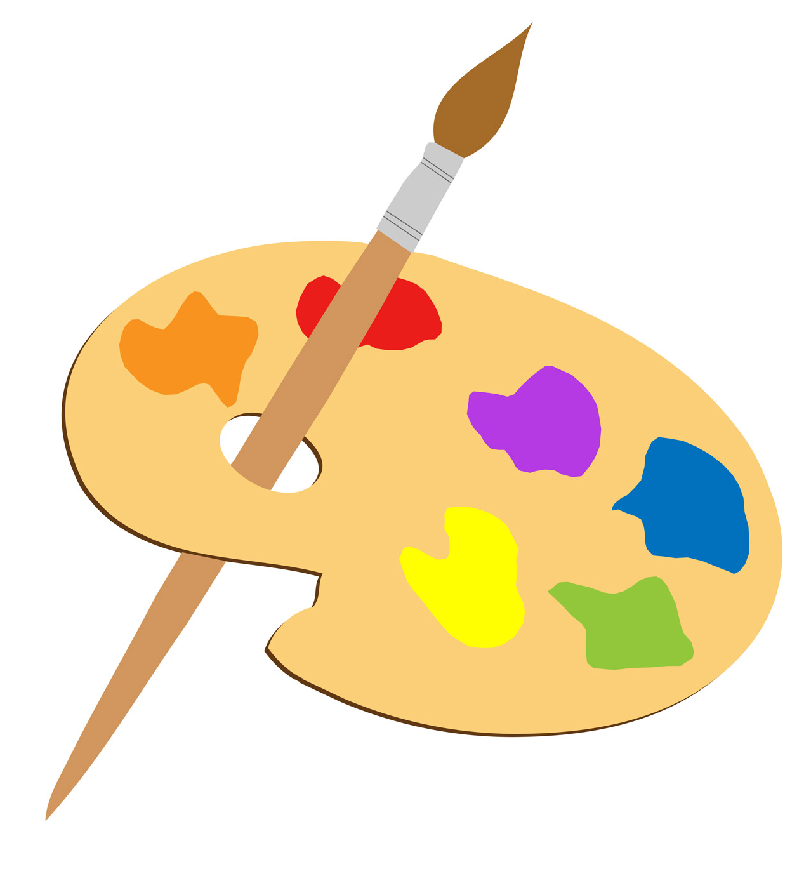
Art

- When holding up art materials for your child to look at/choose, position them so they need to turn their heads to look at them.
- Encourage your child to bring their arms into midline when sitting in order to make marks on paper. Painting by pushing balloons around on a tray is a good activity to work on this.
- Attach a piece of paper to a wall and stretch an arm out to use a paintbrush/make fingerprints. If a piece of paper is stuck to a wall, it can be easier for a child to see than if it is on a tray or table as you can put it at their height and position them accordingly. It also encourages them to look up. If you put the paper low down on the wall, your child could go into a prone position on the floor, a wedge or peanut ball; kneel (if appropriate); lie on their side or even roll to reach the paper.
- Put your child’s feet in paint when practising sitting (whether in a chair, on the edge of a sofa, a bench or therapy ball) and encourage them to put their feet down. Your child can also practise having their hands in art materials when in a prone position or kneeling (if appropriate.)

Stories
- When holding up the book for your child to look at, move it/direct your child’s gaze so they are turning their head to look at the book.
- Make sounds from the story e.g. a b ear growling, bang a drum and move the source of the sound so your child is encouraged to turn their head e.g. by growling on either side. You can also encourage your child to use movement to add sounds themselves e.g. by activating a switch or banging a drum.
- Where possible, support your child to hold the book in one hand and use the other to turn a page.
- If using props as part of a sensory story, stretch out arms and/or lean to one side to reach and explore them.

Cause and Effect Toys/Light Toys
- When lying on the floor or a bed, place a toy on one side of your child and encourage them to roll to get to and activate it.
- Hold and move a light toy for your child to follow as they roll round.
- Support your child to activate a cause and effect toy when in a prone position and then to raise their head to observe the results e.g. the lights from a toy just above them.
- Work on bringing hands into midline to activate a toy in a range of positions: in supported seating, sitting with adult assistance, side lying or in a standing frame.

Messy Play
- If working on bringing hands into midline, position messy items in the middle of a chair tray, standing frame tray or table and encourage your child to bring their hands to the centre.
- You can give your child an extra challenge by using items that are heavier and more difficult to manipulate e.g. a heap of cooked spaghetti/bowl of water will create more resistance for your child to push their arms/hands through than shaving foam.
- When rolling, have something fun and messy on either side of your child that they can play with. They can also combine them as they roll and see what happens.
- Messy play can be a really good activity to do in a prone position e.g. when extending arms over a ball or wedge.
- As with the art activity, you could put a piece of paper on a wall for pupils to splat messy things against e.g. paint, shaving foam, cooked spaghetti.

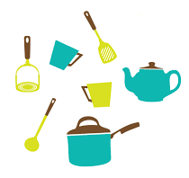
Cooking
- Take every opportunity to make noise with your ingredients e.g. shake pasta inside a pan and position it so that your child might raise/turn their head towards the sound. You can do the same with smell too. If your child likes the smell of a particular ingredient, you can hold it above or to the side, so they move their head toward it.
- There are lots of opportunities to stretch/use arms when cooking e.g. stirring, pushing a rolling pin. If possible, support your child to use both arms at once e.g. position one arm on the side of a bowl to keep it steady as they are assisted to use the other arm to stir; grip dough in one hand and push a rolling pin with another.

Exercises and educational activities
Ball games
- Football: keep one foot flat on a footplate or floor whilst sitting and lift one leg to kick a ball.
- Basketball: secure a ball between your arms then push forward to get it into a box or bucket and listen to the noise.
- Handball: try bouncing a ball against a wall, hear the noise it makes and watch it bounce back (a light up ball would be great for this.)

Relaxation
- If you are using scented lotions during a hand massage, hold them up for your child to smell but position them so your child may lift/turn their head to smell them better.
- If appropriate, support your child to squeeze a lotion bottle or direct their hand into a pot of cream/lotion to scoop some out.
- If giving a hand or foot massage, really stretch out the toes and fingers. You could also incorporate some gentle arm/leg stretches.
- The MOVE body awareness/stretching session (next page) is really good for relaxation.

Body Awareness/Stretching Activity
This can be done at any time and only takes 10 minutes. Put relaxing sounds in the background e.g. by typing in ‘garden sounds’, ‘nature sounds’ or ‘ocean sounds’ into YouTube but it can be anything you like!

Stretch out the toes on one foot (approx 30 seconds.)
Rub the bottom of the foot with your thumb (approx 30 seconds.)
Gently rotate the ankle on the same foot (approx 30 seconds.)
Push the leg up toward the tummy very slowly and hold for 5 seconds (3 times)
Stretch out the toes on the other foot (approx 30 seconds.)
Rub the bottom of the foot with your thumb (approx 30 seconds.)
Gently rotate the ankle on the same foot (approx 30 seconds.)
Push the leg up toward the tummy very slowly and hold for 5 seconds (3 times)
Slowly squeeze both legs at the same time all the way up from the feet to the hips.
Gently wiggle the hips (approx 30 seconds.)
Squeeze all the way up the trunk to the shoulders.
Squeeze the shoulders (approx 30 seconds.)
Stretch out one arm to the side and stretch out the fingers (3 times)
Stretch out the other arm to the side and stretch out the fingers (3 times)
Gently squeeze from the hand all the way up to the head (both sides at once.)

MOVE Sessions
The next three pages are short MOVE sessions with themes we have used in the past. They have been altered so there are no expensive/inaccessible props that will be difficult to get hold of. You could start each group by doing the body awareness/stretching activity included in this booklet.
You will see that there are options for what you can do for some of the songs/activities. For these, choose the ones that are the most appropriate for your child. If you don’t have time for the whole session, just pick a few! If you have any questions regarding how to best support your child to take part in these sessions, please get in touch!
You can find all of the songs on YouTube if you type the name of the song into the search bar. Don’t be afraid to change the songs and make up your own themes. Let us know if you do!

MOVE Session 1: Disney
Song | Exercise/activity
A Whole New World | Position your child on cushions and wave a piece of material above them for a flying carpet. If they are able to do so themselves (or if you have another person available to help them), they can stretch their arms up to try and touch it.
Heigh-Ho | Cycling legs
Let it Go | Cut up a few pieces of white paper into small squares to act as snow.  Get into a prone position (on tummy) on cushions, a wedge, roll or ball and raise head to watch the snow fall. Your child can also move their hands around in the fallen paper to move the snow.
Life is a Highway | Whilst in a prone position, roll a ball or balloon up and down your child’s body.
Getcha Head in the Game | Option 1) Sit behind your child whilst they are in a long sitting position (legs stretched out) and move forwards to push a ball into a box or bucket.  Option 2) Move forwards when kneeling at or sitting on a therapy ball to push a ball into a bucket.  Option 3) Support your child to sit on a bench (or alternative) and move forwards to push a ball into a bucket.
Under the Sea | Sit behind your child whilst they are in a long sitting position (legs stretched out) on the floor or when on a bench. Support them to move their arms as though swimming. Use bubbles or water spray for an underwater effect!
You Can Fly | Whilst in a long sitting position or sitting on a therapy bench (or similar), support your child to stretch their arms out and move from side to side as you fly!

MOVE Session 2: Musicals
Song | Exercise/activity
Greatest Show (Greatest Showman) | Turn the lights off and support your child to roll to either side and bring their heads round to follow a light up toy or torch.
We Go Together (Grease) | Position your child in prone on cushions or a wedge. Prop yourself up in a prone position opposite them and push a ball between you. If your child needs support in a prone position, help them push a ball forwards and backwards as you keep them in position.
You Can’t Stop the Beat (Hairspray) | Support your child to roll onto their side to hit a drum (or anything that makes a bash.)
Mamma Mia | Option 1) Sit behind your child whilst they are in a long sitting position (legs stretched out) and move forwards and backwards.  Option 2) Move forwards and backwards whilst kneeling at a therapy ball (slowly and gently.)  Option 3) Support your child to sit on a bench (or alternative) or therapy ball to move forwards and backwards.  If you have a second person available, have them sit in front of your child and you can pass a ball (or anything you feel like!) back and forth.
Another One Bites the Dust (We Will Rock You) | Whilst supporting your child in a long sitting position or sitting on a therapy bench (or similar), make punching motions by stretching out one arm at a time.
Supercalifragalisticexpialidocious (Mary Poppins) | Whilst supporting your child in a long sitting position or sitting on a therapy bench (or similar), shake your arms as fast as you can. If you have something to wave like a small piece of colourful material or a pompom, even better!

MOVE Session 3: MOVE group favourites!
Song | Exercise/activity
Bicycle Race | Cycling legs exercises
Move It Move It | Choose a second exercise from your child’s physio programme e.g. bridging, abductors.
Splish Splash | Get into a prone position (on your tummy) on cushions, a wedge, roll or ball and raise head to watch bubbles go by!
Roll Over Beethoven | Support/guide your child to roll over, secure a ball between their arms and then push it to your or another family member.
Oops Upside Your Head | Option 1) Sit behind your child whilst they are in a long sitting position (legs stretched out) and move forwards, backwards and side to side.  Option 2) Move forwards and backwards whilst kneeling at a therapy ball (slowly and gently.)  Option 3) Support your child to sit on a bench (or alternative) or therapy ball to move forwards, backwards and side-to-side.
Surfin’ USA | Option 1) Sit behind your child whilst they are in a long sitting position (legs stretched out) and stretch out their arms in swimming motions one at a time.  Option 2) Support your child to sit on a bench (or alternative) or therapy ball and stretch out their arms in swimming motions one at a time.  If you have a water spray or bubbles, add them for an extra effect!
Follow the Leader (our favourite MOVE song.) | Sit behind your child whilst supporting them in long sitting or on a bench (or similar) and follow the dance moves in the song.

